***OUTPUT:***

>setwd("C:/Users/Shraddha/Downloads")

#Set the working directory to the location of the desired file.

>airlines<-read.csv(paste("SixAirlines.csv",sep="."))

#Read the data set into a data frame.

>View(airlines)

#View the data frame -"airlines"

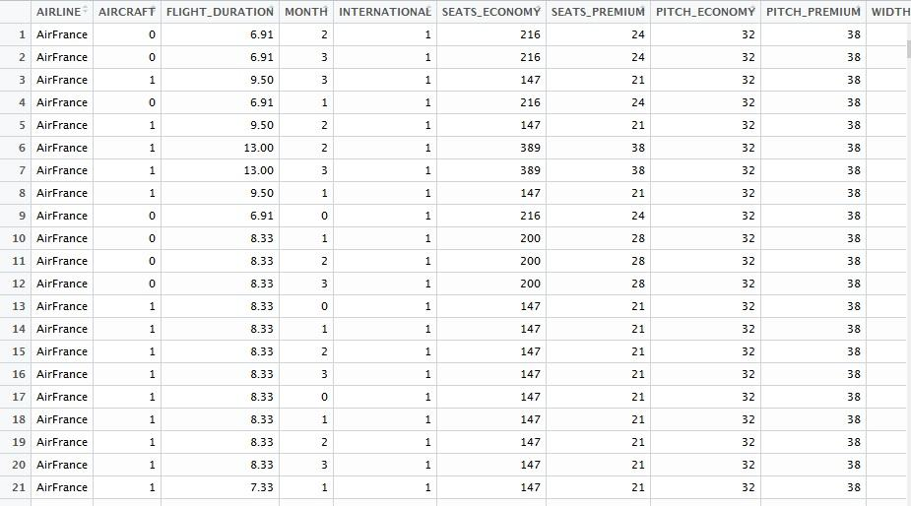

# Obtaining the summary statistics of the Airline data set

>summary(airlines)

AIRLINE AIRCRAFT FLIGHT_DURATION MONTH INTERNATIONAL

AirFrance: 74 Min. :0.0000 Min. : 1.250 Min. :0.000 Min. :0.0000

British :175 1st Qu.:0.0000 1st Qu.: 4.250 1st Qu.:1.000 1st Qu.:1.0000

Delta : 46 Median :0.0000 Median : 7.750 Median :2.000 Median :1.0000

Jet : 65 Mean :0.3268 Mean : 7.549 Mean :1.671 Mean :0.9134

Singapore: 40 3rd Qu.:1.0000 3rd Qu.:10.500 3rd Qu.:3.000 3rd Qu.:1.0000

Virgin : 62 Max. :1.0000 Max. :14.660 Max. :3.000 Max. :1.0000

SEATS_ECONOMY SEATS_PREMIUM PITCH_ECONOMY PITCH_PREMIUM WIDTH_ECONOMY

Min. : 17.0 Min. : 8.00 Min. :30.00 Min. :34.00 Min. :17.00

1st Qu.:127.0 1st Qu.:21.00 1st Qu.:31.00 1st Qu.:38.00 1st Qu.:17.00

Median :185.0 Median :36.00 Median :31.00 Median :38.00 Median :18.00

Mean :200.7 Mean :33.54 Mean :31.21 Mean :37.92 Mean :17.83

3rd Qu.:243.0 3rd Qu.:40.00 3rd Qu.:32.00 3rd Qu.:38.00 3rd Qu.:18.00

Max. :389.0 Max. :66.00 Max. :33.00 Max. :40.00 Max. :19.00

WIDTH_PREMIUM PRICE_ECONOMY PRICE_PREMIUM PRICE_RELATIVE N

Min. :17.00 Min. : 65.0 Min. : 86 Min. :0.0200 Min. : 38.0

1st Qu.:19.00 1st Qu.: 404.8 1st Qu.: 524 1st Qu.:0.1000 1st Qu.:162.0

Median :19.00 Median :1224.0 Median :1710 Median :0.3800 Median :227.0

Mean :19.48 Mean :1317.1 Mean :1832 Mean :0.4926 Mean :234.2

3rd Qu.:21.00 3rd Qu.:1903.0 3rd Qu.:2989 3rd Qu.:0.7475 3rd Qu.:279.0

Max. :21.00 Max. :3593.0 Max. :7414 Max. :1.8900 Max. :441.0

LAMBDA QUALITY

Min. :0.0500 Min. : 2.000

1st Qu.:0.1200 1st Qu.: 6.000

Median :0.1300 Median : 7.000

Mean :0.1503 Mean : 6.716

3rd Qu.:0.1500 3rd Qu.: 7.000

Max. :0.5500 Max. :10.000

> library(psych)

> describe(airlines)

vars n mean sd median trimmed mad min

AIRLINE* 1 462 3.02 1.65 2.00 2.90 1.48 1.00

AIRCRAFT 2 462 0.33 0.47 0.00 0.28 0.00 0.00

FLIGHT_DURATION 3 462 7.55 3.54 7.75 7.54 4.82 1.25

MONTH 4 462 1.67 1.05 2.00 1.71 1.48 0.00

INTERNATIONAL 5 462 0.91 0.28 1.00 1.00 0.00 0.00

SEATS_ECONOMY 6 462 200.71 77.96 185.00 193.76 85.99 17.00

SEATS_PREMIUM 7 462 33.54 13.26 36.00 33.20 11.86 8.00

PITCH_ECONOMY 8 462 31.21 0.66 31.00 31.25 0.00 30.00

PITCH_PREMIUM 9 462 37.92 1.32 38.00 38.06 0.00 34.00

WIDTH_ECONOMY 10 462 17.83 0.56 18.00 17.81 0.00 17.00

WIDTH_PREMIUM 11 462 19.48 1.10 19.00 19.54 0.00 17.00

PRICE_ECONOMY 12 462 1317.06 989.81 1224.00 1231.30 1163.84 65.00

PRICE_PREMIUM 13 462 1832.35 1289.97 1710.00 1782.94 1852.51 86.00

PRICE_RELATIVE 14 462 0.49 0.45 0.38 0.43 0.42 0.02

N 15 462 234.25 86.88 227.00 227.69 90.44 38.00

LAMBDA 16 462 0.15 0.06 0.13 0.14 0.03 0.05

QUALITY 17 462 6.72 1.78 7.00 6.79 0.00 2.00

max range skew kurtosis se

AIRLINE* 6.00 5.00 0.59 -0.95 0.08

AIRCRAFT 1.00 1.00 0.74 -1.46 0.02

FLIGHT_DURATION 14.66 13.41 -0.05 -1.12 0.16

MONTH 3.00 3.00 -0.16 -1.20 0.05

INTERNATIONAL 1.00 1.00 -2.93 6.60 0.01

SEATS_ECONOMY 389.00 372.00 0.61 -0.26 3.63

SEATS_PREMIUM 66.00 58.00 0.25 -0.46 0.62

PITCH_ECONOMY 33.00 3.00 -0.03 -0.38 0.03

PITCH_PREMIUM 40.00 6.00 -1.48 3.43 0.06

WIDTH_ECONOMY 19.00 2.00 -0.03 -0.12 0.03

WIDTH_PREMIUM 21.00 4.00 -0.09 -0.34 0.05

PRICE_ECONOMY 3593.00 3528.00 0.52 -0.88 46.05

PRICE_PREMIUM 7414.00 7328.00 0.51 0.41 60.01

PRICE_RELATIVE 1.89 1.87 1.14 0.61 0.02

N 441.00 403.00 0.61 -0.44 4.04

LAMBDA 0.55 0.50 2.70 14.02 0.00

QUALITY 10.00 8.00 -0.51 1.67 0.08

> table(airlines$AIRLINE)

AirFrance British Delta Jet Singapore Virgin

74 175 46 65 40 62

> plot(x=airlines$AIRLINE,y=airlines$PRICE_ECONOMY)

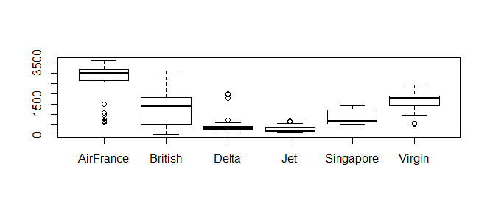

> plot(x=airlines$AIRLINE,y=airlines$PRICE_PREMIUM)

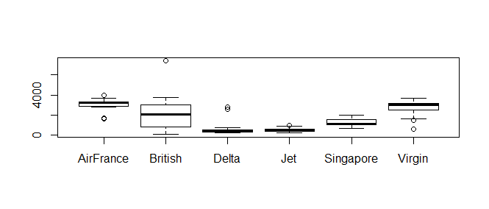

> barchart(airlines$AIRLINE,airlines$PRICE_RELATIVE,data=airlines,xlab="Relative Price",ylab="Airline",main="Variation of airline with relative price ",col=c("grey"))

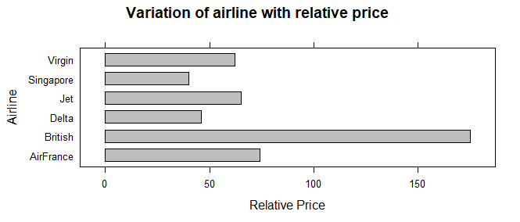

> mytable1<-xtabs(~airlines$AIRLINE+airlines$PRICE_ECONOMY)

> chisq.test(mytable1)

Pearson's Chi-squared test

data: mytable1

X-squared = 2177.7, df = 950, p-value < 2.2e-16

> mytable2<-xtabs(~airlines$AIRLINE+airlines$PRICE_PREMIUM)

> chisq.test(mytable2)

Pearson's Chi-squared test

data: mytable2

X-squared = 2200.5, df = 850, p-value < 2.2e-16

Warning message:

In chisq.test(mytable2) : Chi-squared approximation may be incorrect

> mytable3<-xtabs(~airlines$AIRLINE+airlines$PRICE_RELATIVE)

> chisq.test(mytable3)

Pearson's Chi-squared test

data: mytable3

X-squared = 1408, df = 485, p-value < 2.2e-16

Warning message:

In chisq.test(mytable3) : Chi-squared approximation may be incorrect

(not explained yet)

> fit1<-lm(airlines$PRICE_RELATIVE~airlines$AIRCRAFT)

> summary(fit1)

Call:

lm(formula = airlines$PRICE_RELATIVE ~ airlines$AIRCRAFT)

Residuals:

Min 1Q Median 3Q Max

-0.5004 -0.3590 -0.1504 0.2396 1.3596

Coefficients:

Estimate Std. Error t value Pr(>|t|)

(Intercept) 0.53045 0.02553 20.77 <2e-16 ***

airlines$AIRCRAFT -0.11568 0.04466 -2.59 0.0099 **

---

Signif. codes: 0 ‘***’ 0.001 ‘**’ 0.01 ‘*’ 0.05 ‘.’ 0.1 ‘ ’ 1

Residual standard error: 0.4503 on 460 degrees of freedom

Multiple R-squared: 0.01437, Adjusted R-squared: 0.01223

F-statistic: 6.708 on 1 and 460 DF, p-value: 0.0099

> fit2<-lm(airlines$PRICE_RELATIVE~airlines$FLIGHT_DURATION)

> summary(fit2)

Call:

lm(formula = airlines$PRICE_RELATIVE ~ airlines$FLIGHT_DURATION)

Residuals:

Min 1Q Median 3Q Max

-0.5481 -0.3465 -0.1204 0.2492 1.4569

Coefficients:

Estimate Std. Error t value Pr(>|t|)

(Intercept) 0.388079 0.049453 7.847 3e-14 ***

airlines$FLIGHT_DURATION 0.013851 0.005932 2.335 0.02 *

---

Signif. codes: 0 ‘***’ 0.001 ‘**’ 0.01 ‘*’ 0.05 ‘.’ 0.1 ‘ ’ 1

Residual standard error: 0.4509 on 460 degrees of freedom

Multiple R-squared: 0.01171, Adjusted R-squared: 0.009564

F-statistic: 5.452 on 1 and 460 DF, p-value: 0.01998

> fit3<-lm(airlines$PRICE_ECONOMY~airlines$SEATS_ECONOMY)

> summary(fit3)

Call:

lm(formula = airlines$PRICE_ECONOMY ~ airlines$SEATS_ECONOMY)

Residuals:

Min 1Q Median 3Q Max

-1452.4 -848.5 -42.0 623.3 2326.2

Coefficients:

Estimate Std. Error t value Pr(>|t|)

(Intercept) 939.5039 126.0370 7.454 4.53e-13 ***

airlines$SEATS_ECONOMY 1.8811 0.5854 3.213 0.0014 **

---

Signif. codes: 0 ‘***’ 0.001 ‘**’ 0.01 ‘*’ 0.05 ‘.’ 0.1 ‘ ’ 1

Residual standard error: 979.9 on 460 degrees of freedom

Multiple R-squared: 0.02195, Adjusted R-squared: 0.01983

F-statistic: 10.32 on 1 and 460 DF, p-value: 0.001405

> fit4<-lm(airlines$PRICE_PREMIUM~airlines$SEATS_PREMIUM)

> summary(fit4)

Call:

lm(formula = airlines$PRICE_PREMIUM ~ airlines$SEATS_PREMIUM)

Residuals:

Min 1Q Median 3Q Max

-2216.2 -1035.1 -127.1 1069.2 5790.5

Coefficients:

Estimate Std. Error t value Pr(>|t|)

(Intercept) 1097.998 159.412 6.888 1.87e-11 ***

airlines$SEATS_PREMIUM 21.895 4.421 4.953 1.03e-06 ***

---

Signif. codes: 0 ‘***’ 0.001 ‘**’ 0.01 ‘*’ 0.05 ‘.’ 0.1 ‘ ’ 1

Residual standard error: 1258 on 460 degrees of freedom

Multiple R-squared: 0.05062, Adjusted R-squared: 0.04856

F-statistic: 24.53 on 1 and 460 DF, p-value: 1.03e-06

> cor(airlines[,c(6,12)])

SEATS_ECONOMY PRICE_ECONOMY

SEATS_ECONOMY 1.0000000 0.1481638

PRICE_ECONOMY 0.1481638 1.0000000

> cor(airlines[,c(7,13)])

SEATS_PREMIUM PRICE_PREMIUM

SEATS_PREMIUM 1.0000000 0.2249974

PRICE_PREMIUM 0.2249974 1.0000000

>fit5<-lm(I(airlines$PITCH_PREMIUM-airlines$PITCH_ECONOMY)~airlines$PRICE_RELATIVE)

> summary(fit5)

Call:

lm(formula = I(airlines$PITCH_PREMIUM - airlines$PITCH_ECONOMY) ~

airlines$PRICE_RELATIVE)

Residuals:

Min 1Q Median 3Q Max

-4.0521 -0.6158 0.1566 0.7218 3.9856

Coefficients:

Estimate Std. Error t value Pr(>|t|)

(Intercept) 5.7884 0.1076 53.80 <2e-16 ***

airlines$PRICE_RELATIVE 1.8839 0.1608 11.71 <2e-16 ***

---

Signif. codes: 0 ‘***’ 0.001 ‘**’ 0.01 ‘*’ 0.05 ‘.’ 0.1 ‘ ’ 1

Residual standard error: 1.565 on 460 degrees of freedom

Multiple R-squared: 0.2298, Adjusted R-squared: 0.2281

F-statistic: 137.2 on 1 and 460 DF, p-value: < 2.2e-16

>fit6<-lm(I(airlines$WIDTH_PREMIUM-airlines$WIDTH_ECONOMY)~airlines$PRICE_RELATIVE)

> summary(fit6)

Call:

lm(formula = I(airlines$WIDTH_PREMIUM - airlines$WIDTH_ECONOMY) ~

airlines$PRICE_RELATIVE)

Residuals:

Min 1Q Median 3Q Max

-2.0620 -0.6898 -0.2280 0.8880 2.8380

Coefficients:

Estimate Std. Error t value Pr(>|t|)

(Intercept) 1.00369 0.07197 13.95 <2e-16 ***

airlines$PRICE_RELATIVE 1.31941 0.10758 12.26 <2e-16 ***

---

Signif. codes: 0 ‘***’ 0.001 ‘**’ 0.01 ‘*’ 0.05 ‘.’ 0.1 ‘ ’ 1

Residual standard error: 1.047 on 460 degrees of freedom

Multiple R-squared: 0.2464, Adjusted R-squared: 0.2448

F-statistic: 150.4 on 1 and 460 DF, p-value: < 2.2e-16

> fit7<-lm(I(airlines$SEATS_ECONOMY)~airlines$PRICE_RELATIVE)

> summary(fit7)

Call:

lm(formula = I(airlines$SEATS_ECONOMY) ~ airlines$PRICE_RELATIVE)

Residuals:

Min 1Q Median 3Q Max

-183.04 -70.81 -15.00 41.90 191.11

Coefficients:

Estimate Std. Error t value Pr(>|t|)

(Intercept) 202.785 5.365 37.796 <2e-16 ***

airlines$PRICE_RELATIVE -4.217 8.020 -0.526 0.599

---

Signif. codes: 0 ‘***’ 0.001 ‘**’ 0.01 ‘*’ 0.05 ‘.’ 0.1 ‘ ’ 1

Residual standard error: 78.02 on 460 degrees of freedom

Multiple R-squared: 0.0006007, Adjusted R-squared: -0.001572

F-statistic: 0.2765 on 1 and 460 DF, p-value: 0.5993

> fit8<-lm(I(airlines$SEATS_PREMIUM)~airlines$PRICE_RELATIVE)

> summary(fit8)

Call:

lm(formula = I(airlines$SEATS_PREMIUM) ~ airlines$PRICE_RELATIVE)

Residuals:

Min 1Q Median 3Q Max

-26.708 -10.990 2.170 6.108 33.959

Coefficients:

Estimate Std. Error t value Pr(>|t|)

(Intercept) 35.0846 0.9073 38.669 <2e-16 ***

airlines$PRICE_RELATIVE -3.1374 1.3562 -2.313 0.0211 *

---

Signif. codes: 0 ‘***’ 0.001 ‘**’ 0.01 ‘*’ 0.05 ‘.’ 0.1 ‘ ’ 1

Residual standard error: 13.19 on 460 degrees of freedom

Multiple R-squared: 0.0115, Adjusted R-squared: 0.009351

F-statistic: 5.351 on 1 and 460 DF, p-value: 0.02115

>fit9<-lm(I(airlines$SEATS_PREMIUM-airlines$SEATS_ECONOMY)~airlines$PRICE_RELATIVE)

> summary(fit9)

Call:

lm(formula = I(airlines$SEATS_PREMIUM - airlines$SEATS_ECONOMY) ~

airlines$PRICE_RELATIVE)

Residuals:

Min 1Q Median 3Q Max

-184.55 -39.69 11.05 57.68 171.00

Coefficients:

Estimate Std. Error t value Pr(>|t|)

(Intercept) -167.701 4.847 -34.597 <2e-16 ***

airlines$PRICE_RELATIVE 1.080 7.246 0.149 0.882

---

Signif. codes: 0 ‘***’ 0.001 ‘**’ 0.01 ‘*’ 0.05 ‘.’ 0.1 ‘ ’ 1

Residual standard error: 70.49 on 460 degrees of freedom

Multiple R-squared: 4.828e-05, Adjusted R-squared: -0.002126

F-statistic: 0.02221 on 1 and 460 DF, p-value: 0.8816

>fit10<-lm(I(airlines$SEATS_ECONOMY-airlines$SEATS_PREMIUM)~I(airlines$PRICE_PREMIUM-airlines$PRICE_ECONOMY))

> summary(fit10)

Call:

lm(formula = I(airlines$SEATS_ECONOMY - airlines$SEATS_PREMIUM) ~

I(airlines$PRICE_PREMIUM - airlines$PRICE_ECONOMY))

Residuals:

Min 1Q Median 3Q Max

-165.590 -50.882 -7.618 35.809 191.679

Coefficients:

Estimate Std. Error t value Pr(>|t|)

(Intercept) 1.581e+02 4.335e+00 36.474 < 2e-16

I(airlines$PRICE_PREMIUM - airlines$PRICE_ECONOMY) 1.758e-02 5.579e-03 3.152 0.00173

(Intercept) ***

I(airlines$PRICE_PREMIUM - airlines$PRICE_ECONOMY) **

---

Signif. codes: 0 ‘***’ 0.001 ‘**’ 0.01 ‘*’ 0.05 ‘.’ 0.1 ‘ ’ 1

Residual standard error: 69.74 on 460 degrees of freedom

Multiple R-squared: 0.02114, Adjusted R-squared: 0.01901

F-statistic: 9.936 on 1 and 460 DF, p-value: 0.001727

>fit11<-lm(I(airlines$PITCH_PREMIUM-airlines$PITCH_ECONOMY)~I(airlines$PRICE_PREMIUM-airlines$PRICE_ECONOMY))

> summary(fit11)

Call:

lm(formula = I(airlines$PITCH_PREMIUM - airlines$PITCH_ECONOMY) ~

I(airlines$PRICE_PREMIUM - airlines$PRICE_ECONOMY))

Residuals:

Min 1Q Median 3Q Max

-4.5474 -0.5955 0.1032 0.3891 3.4472

Coefficients:

Estimate Std. Error t value Pr(>|t|)

(Intercept) 6.5316331 0.1100413 59.356 <2e-16

I(airlines$PRICE_PREMIUM - airlines$PRICE_ECONOMY) 0.0003587 0.0001416 2.533 0.0117

(Intercept) ***

I(airlines$PRICE_PREMIUM - airlines$PRICE_ECONOMY) *

---

Signif. codes: 0 ‘***’ 0.001 ‘**’ 0.01 ‘*’ 0.05 ‘.’ 0.1 ‘ ’ 1

Residual standard error: 1.77 on 460 degrees of freedom

Multiple R-squared: 0.01375, Adjusted R-squared: 0.01161

F-statistic: 6.415 on 1 and 460 DF, p-value: 0.01165

>fit12<-lm(I(airlines$WIDTH_PREMIUM-airlines$WIDTH_ECONOMY)~I(airlines$PRICE_PREMIUM-airlines$PRICE_ECONOMY))

> summary(fit12)

Call:

lm(formula = I(airlines$WIDTH_PREMIUM - airlines$WIDTH_ECONOMY) ~

I(airlines$PRICE_PREMIUM - airlines$PRICE_ECONOMY))

Residuals:

Min 1Q Median 3Q Max

-1.5506 -0.6921 -0.5760 1.1077 2.4461

Coefficients:

Estimate Std. Error t value Pr(>|t|)

(Intercept) 1.5409683 0.0745157 20.680 <2e-16

I(airlines$PRICE_PREMIUM - airlines$PRICE_ECONOMY) 0.0002187 0.0000959 2.281 0.023

(Intercept) ***

I(airlines$PRICE_PREMIUM - airlines$PRICE_ECONOMY) *

---

Signif. codes: 0 ‘***’ 0.001 ‘**’ 0.01 ‘*’ 0.05 ‘.’ 0.1 ‘ ’ 1

Residual standard error: 1.199 on 460 degrees of freedom

Multiple R-squared: 0.01118, Adjusted R-squared: 0.009034

F-statistic: 5.203 on 1 and 460 DF, p-value: 0.02301

>fit13<-lm(airlines$FLIGHT_DURATION~I(airlines$PRICE_PREMIUM-airlines$PRICE_ECONOMY))

> summary(fit13)

Call:

lm(formula = airlines$FLIGHT_DURATION ~ I(airlines$PRICE_PREMIUM -

airlines$PRICE_ECONOMY))

Residuals:

Min 1Q Median 3Q Max

-4.9141 -2.5970 -0.4307 2.1607 8.0836

Coefficients:

Estimate Std. Error t value Pr(>|t|)

(Intercept) 6.0631392 0.1939338 31.26 <2e-16

I(airlines$PRICE_PREMIUM - airlines$PRICE_ECONOMY) 0.0028836 0.0002496 11.55 <2e-16

(Intercept) ***

I(airlines$PRICE_PREMIUM - airlines$PRICE_ECONOMY) ***

---

Signif. codes: 0 ‘***’ 0.001 ‘**’ 0.01 ‘*’ 0.05 ‘.’ 0.1 ‘ ’ 1

Residual standard error: 3.12 on 460 degrees of freedom

Multiple R-squared: 0.2249, Adjusted R-squared: 0.2232

F-statistic: 133.5 on 1 and 460 DF, p-value: < 2.2e-16

>cor(x=I(airlines$FLIGHT_DURATION),y=I(airlines$PRICE_PREMIUM-airlines$PRICE_ECONOMY))

[1] 0.4742638

> cor(x=I(airlines$MONTH),y=I(airlines$PRICE_PREMIUM-airlines$PRICE_ECONOMY))

[1] 0.03687665

> cor.test(airlines$MONTH,I(airlines$PRICE_PREMIUM-airlines$PRICE_ECONOMY))

Pearson's product-moment correlation

data: airlines$MONTH and I(airlines$PRICE_PREMIUM - airlines$PRICE_ECONOMY)

t = 0.79145, df = 460, p-value = 0.4291

alternative hypothesis: true correlation is not equal to 0

95 percent confidence interval:

-0.05453574 0.12767604

sample estimates:

cor

0.03687665

> cor.test(airlines$QUALITY,I(airlines$PRICE_PREMIUM-airlines$PRICE_ECONOMY))

Pearson's product-moment correlation

data: airlines$QUALITY and I(airlines$PRICE_PREMIUM - airlines$PRICE_ECONOMY)

t = 2.5327, df = 460, p-value = 0.01165

alternative hypothesis: true correlation is not equal to 0

95 percent confidence interval:

0.02632507 0.20629420

sample estimates:

cor

0.1172723

> cor.test(airlines$AIRCRAFT,I(airlines$PRICE_PREMIUM-airlines$PRICE_ECONOMY))

Pearson's product-moment correlation

data: airlines$AIRCRAFT and I(airlines$PRICE_PREMIUM - airlines$PRICE_ECONOMY)

t = -0.40431, df = 460, p-value = 0.6862

alternative hypothesis: true correlation is not equal to 0

95 percent confidence interval:

-0.10988755 0.07250602

sample estimates:

cor

-0.01884757

> fit15<-lm(airlines$AIRCRAFT~I(airlines$PRICE_PREMIUM-airlines$PRICE_ECONOMY))

> coefficients(fit15)

(Intercept)

3.346723e-01

I(airlines$PRICE_PREMIUM - airlines$PRICE_ECONOMY)

-1.520033e-05

> t.test(I(airlines$PRICE_PREMIUM-airlines$PRICE_ECONOMY)~airlines$AIRCRAFT)

Welch Two Sample t-test

data: I(airlines$PRICE_PREMIUM - airlines$PRICE_ECONOMY) by airlines$AIRCRAFT

t = 0.42383, df = 336.25, p-value = 0.672

alternative hypothesis: true difference in means is not equal to 0

95 percent confidence interval:

-85.09374 131.83363

sample estimates:

mean in group 0 mean in group 1

522.9196 499.5497

> t.test(I(airlines$PRICE_PREMIUM)~airlines$AIRCRAFT)

Welch Two Sample t-test

data: I(airlines$PRICE_PREMIUM) by airlines$AIRCRAFT

t = -0.43785, df = 309.53, p-value = 0.6618

alternative hypothesis: true difference in means is not equal to 0

95 percent confidence interval:

-303.2518 192.8561

sample estimates:

mean in group 0 mean in group 1

1814.305 1869.503

> t.test(I(airlines$PRICE_ECONOMY)~airlines$AIRCRAFT)

Welch Two Sample t-test

data: I(airlines$PRICE_ECONOMY) by airlines$AIRCRAFT

t = -0.79106, df = 288.69, p-value = 0.4296

alternative hypothesis: true difference in means is not equal to 0

95 percent confidence interval:

-274.0507 116.9151

sample estimates:

mean in group 0 mean in group 1

1291.386 1369.954

>library(ggplot2)

>ggplot(airlines, aes(x = AIRLINE, fill = AIRLINE)) + geom_bar()

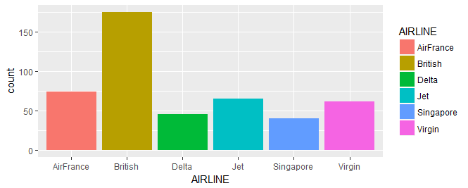

>ggplot(data.df, aes(x = INTERNATIONAL))+ geom_bar()

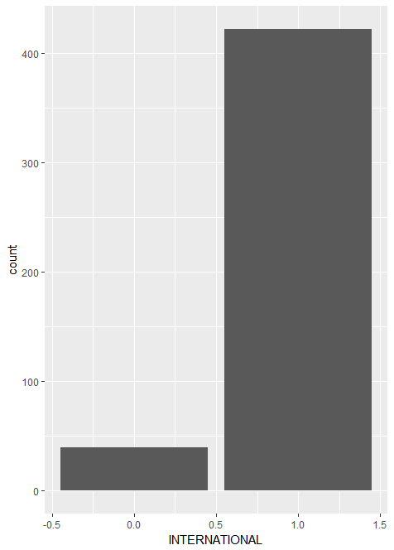

>plot(airlines$FLIGHT_DURATION,airlines$PRICE_ECONOMY,

+ col="green",

+ main="Price economy vs flight hours",

+ xlab="Hours", ylab="Price")

> abline(h=mean(airlines$PRICE_ECONOMY), col="black", lty="dotted")

> abline(v=mean(airlines$FLIGHT_DURATION), col="black", lty="dotted")

> abline(lm(airlines$PRICE_ECONOMY ~ airlines$FLIGHT_DURATION))

